**Control Structures**

Program:

Scenario 1:

**Scenario 1:** The bank wants to apply a discount to loan interest rates for customers above 60 years old.

* + **Question:** Write a PL/SQL block that loops through all customers, checks their age, and if they are above 60, apply a 1% discount to their current loan interest rates.

1. SET SERVEROUTPUT ON
2. DECLARE
3. n_Customer_id  Bank.customer_id%TYPE;
4. n_age          Bank.age%TYPE;
5. n_oldRate      Bank.interest_rate%TYPE;
6. n_newRate      Bank.INTEREST_RATE%TYPE;
7. BEGIN
8. FOR records IN(
9. SELECT customer_id , age , interest_rate
10. FROM Bank
11. WHERE age > 60
12. ) LOOP
13. n_Customer_id := records.customer_id;
14. n_age := records.age;
15. n_oldRate := records.interest_rate;
16. n_newRate := n_oldRate - (n_oldRate * 0.01);
17. UPDATE Bank
18. SET interest_rate = n_newRate
19. WHERE customer_id = n_Customer_id;
20. DBMS_OUTPUT.put_line('Updates Customers are ' || n_Customer_id || ' Age ' || n_age || ' Interest rate ' || n_newRate);
21. END LOOP;
22. COMMIT;
23. END;
24. /

Output:

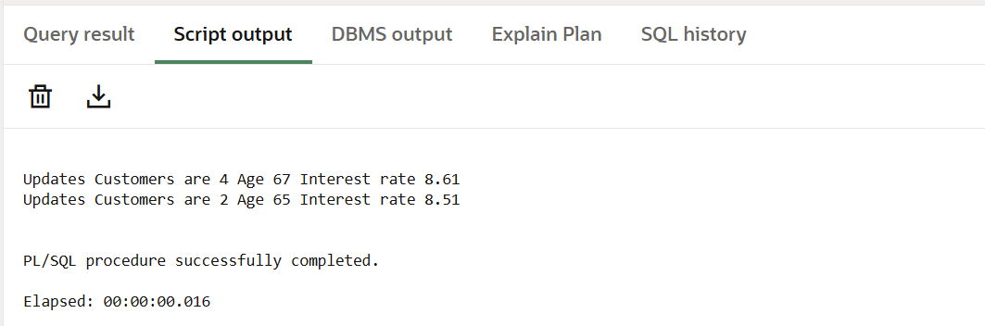

**Scenario 2:** A customer can be promoted to VIP status based on their balance.

* + **Question:** Write a PL/SQL block that iterates through all customers and sets a flag IsVIP to TRUE for those with a balance over $10,000.

BEGIN

    for records in (

        SELECT customer_id, balance

        FROM CUSTOMER

    ) LOOP

        IF records.balance > 10000 THEN

                UPDATE CUSTOMER

                SET status = 'VIP'

                WHERE records.balance > 10000;

                DBMS_OUTPUT.PUT_LINE('The customer ' || records.customer_id || ' is set to VIP');

        ELSE

            UPDATE CUSTOMER

            SET status = 'REGULAR'

            WHERE records.balance <= 10000;

            DBMS_OUTPUT.PUT_Line('The customer ' || records.customer_id || ' is a regular customer');

        END IF;

        END LOOP;

        COMMIT;

        END;

        /

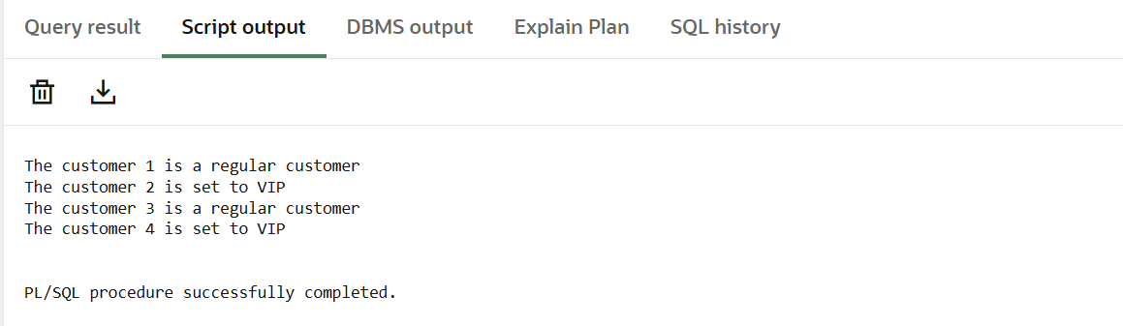

**Scenario 3:** The bank wants to send reminders to customers whose loans are due within the next 30 days.

* + **Question:** Write a PL/SQL block that fetches all loans due in the next 30 days and prints a reminder message for each customer.

Program:

DECLARE

    n_loan_id Loans.LOAN_ID%TYPE;

    n_name Loans.NAME%TYPE;

    n_amount Loans.AMOUNT%TYPE;

    n_due_data Loans.DUE_DATA%TYPE;

BEGIN

    FOR records in(SELECT loan_id, name , amount , due_data

    FROM Loans

    WHERE due_data between SYSDATE AND SYSDATE + 30

    )LOOP

        n_loan_id := records.loan_id;

        n_name := records.name;

        n_amount := records.amount;

        n_due_data := records.due_data;

    dbms_output.put_line('The customer :' || n_loan_id || ' whose name is ' || n_name || ' has to pay ' || n_amount || ' within the next thirty days');

END LOOP;

END;

/

